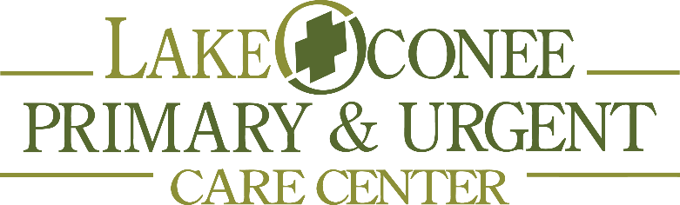

Authorization to Treat Minor

_____________________________________________________________________________________
Name of Child/Minor

_____________________________________________________________________________________Lake Oconee Primary &Urgent Care

As the parent/guardian of the above-named child/minor, I hereby give permission to Lake Oconee Primary & Urgent Care to treat the child/minor in the event that a medical issue arises and I am unable to personally consent to the treatment. I also agree to be responsible to the physician, clinic, lab and all other ancillary service providers for charges incurred relating to medical services rendered.

___________________________________________________________ _______________________
Parent or Guardian’s Signature Date

LAKE OCONEE PRIMARY & URGENT CARE 114 HARMONY CROSSING, SUITE 1 EATONTON, GA 31024
OFF: 706-484-0884 FAX:706-484-0885

